Erick Avalos

Professor Pottie

3 October 2019

ECE 180DA

Lab 1

1. **What you planned to do this week.**

This week, I had planned to complete all the lab requisites and requirements to succeed in the assignments. These requirements included enabling the Raspberry Pi zero to work with Raspbian, enabling SSH via USB connection, enabling a Wireless connection through VNC Viewer, installation of Berryconda, and finally testing the system with a Python script.

1. **What you ended up doing this week. Explain what went wrong, what changed, and what kind of successes you may have had. Include screenshots, graphs, images and other details to best explain what happened.**

Everything that was planned for this week was completed in a timely fashion with nothing going wrong. A script named lab2_output_to_rpi.py was created and pushed to Git. This python script was a for loop from 1 to 6 in which concatenated the for loop index into a string, “This is output: “. The results are shown in figure 1 below

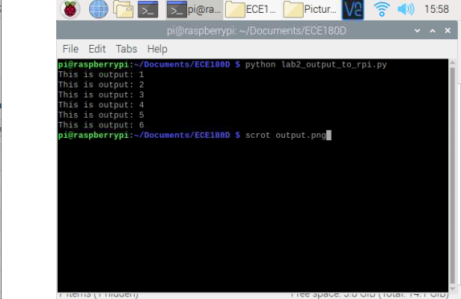

*Figure 1: Lab2 output on terminal*

1. **What you plan to do next week.**

What I plan on doing next week are completing the desired tasks on the Raspberry Pi. This tasks revolve around integrating the BerryIMU with the raspberry pi and be able to pull raw data from it.